Wave Density Experiments

Abstract:
In the experiment we used different density materials and created mechanical waves and measured the difference in amplitude over a distance to find the energy loss. Our hypothesis said that the results would show that the denser the liquid the more resistance there is on a mechanical wave, but our results showed us the opposite. The more dense liquid put up less resistance as you can see in the data table above.
Our theory is that the the denser materials made the mechanical waves go faster and take less time to go through the area therefore losing less energy.

Introduction:
In this project, we are focusing on the amplitude, or height, of waves and how different densities, how thick a liquid is, affect the amplitude of the waves over a distance. As a wave degrades over time it loses energy, and a wave will bend if the depth of a medium is changed, going from deep to shallow. In this experiment we used a long, clear tupperware bucket to hold our water, rulers to measure the distance of the troughs and crests, slow motion cameras for replay, and a wooden block to create the initial waves. We wanted to focus on this topic for our project because we were interested in discovering the amazing properties of liquid waves and the what type of materials can conduct a wave.

Question and Hypothesis:
How does the density of the medium affect energy loss on mechanical waves?
If the medium is more dense, than the faster a wave will decay because more particles are bumping into each other and creating more energy loss due to friction.

Materials and Method:
- 6.5x14 in clear tub.
- 3 metal rulers
- Wooden block
- Salt
- Water
- Oil
- Iphones for filming in Slow Motion

For our experiment we used rulers to measure the depth and frequency of the waves as they traveled through the medium. We used the slow motion option on our camera phones in order to video and review the data that we recorded. On the bottom of our tank we had a longer ruler laid out to see how the distance of the waves change over time and how different materials slow the crests of the waves.
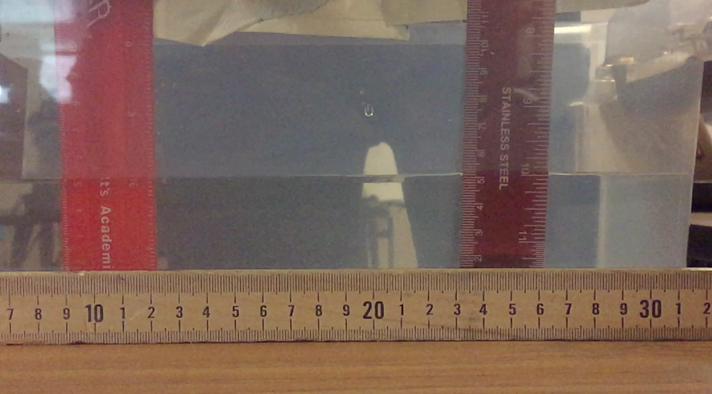

Results:
Wave Tank Experiments:
This table is showing the data that we collected from our experiments. The wave medium is what type of liquid we used, crests are the top of a wave and how far apart two of them are, depth is how deep the liquid is, and amplitude is the height of the wave from the centerline.
Wave medium | Distance- Crests | Depth- Still | Amplitude
water -1.0 | 15cm | 5cm | 1st 6cm- 2nd 5.5cm
Salt water-1.025 | 10cm | 5cm | 1st 5.5 -2nd 5.25cm
Vegetable oil oil - 0.9 | 11cm | 5cm | 1st 6 2nd 5.25
http://www.engineeringtoolbox.com/liquids-densities-d_743.html

Discussion:
For our lab experiments we decided to evaluate the density of a medium and question whether it would change how a wave moved. Our idea for this project came from doing previous experiments involving a wave tank showing how waves move and bend depending on the depth of the water. After we found the subject for our experiment, we discussed at what density of the medium that we would notice a difference in the movements of the waves including the distance of the crests and amplitude of the waves. When we did our first experiment we started with water at different depths in order to get a better wave, and we eventually found that a depth of 5cm had the best results. While we did our experiments we used iphones to video the results. As we moved on from pure water to our second experiment, we added salt to the water to see if a slight increase in density would change the waves drastically.
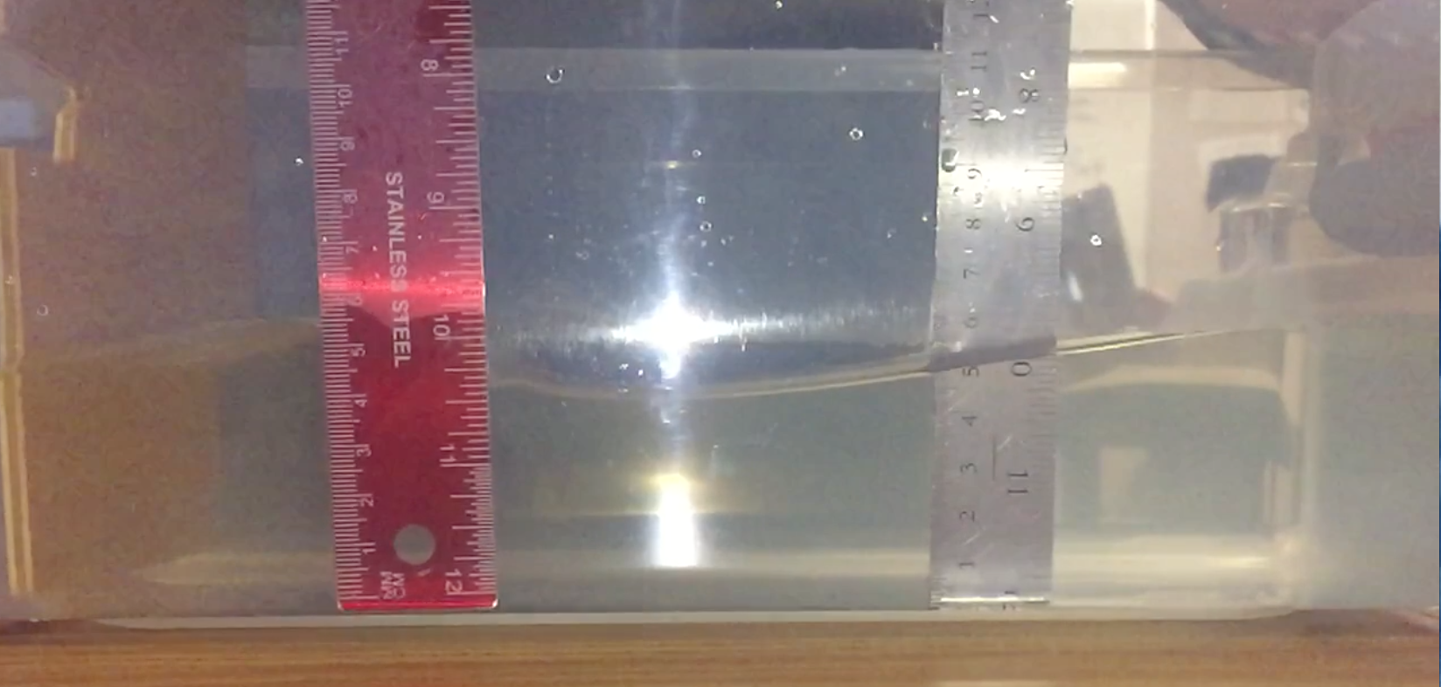
We moved to oil, which seemed to move just a quickly as the pure water but the crests of the waves were closer. In the end we noticed that a slight increase in density did change the waves, but was the opposite of what hypothesis predicted, but was so slight it wasn’t noticeable without slowing the video down. The data showed that the denser the material the the less energy the wave was losing over a distance. Our theory is that the the denser materials made the mechanical waves go faster and take less time to go through the area therefore losing less energy.

Conclusion:
The results from our experiments showed that when a mechanical wave moves through a denser medium it lost less energy over longer distances. Our results also showed that the denser the medium was, the shorter the crests of the waves were, and gave us a greater understanding of waves.

